Sistemi i Detektimit Automatik të Targave dhe Pagesës në Toll

General Description

This document describes the deployment diagram for an automated system that detects vehicle license plates using cameras and artificial intelligence technology, and automatically processes toll payments. The system includes a number of physical and software components that interact in real-time to ensure the efficient and secure operation of the system.

Component Descriptions

Camera Device
Captures vehicle images and sends them for processing.

AI/OCR Module
Uses computer vision (YOLO/OCR) to extract license plate numbers.

Toll System Server
Core system logic: verification, toll calculation, and orchestration.

Vehicle & Toll DB
Stores vehicle registrations, toll rules, passage data.

Payment Gateway
Handles automatic transactions (via Stripe, PayPal, or bank APIs).

Log & Audit Server
Stores critical operations for traceability and legal compliance.

Notification Server
Sends SMS/Email alerts to users or admins.

Admin Interface
Allows toll authority to review, edit, and monitor system events.

User Mobile App
Lets users view their toll payments and receive notifications.

Deployment Diagram
Diagrami i mëposhtëm ilustron se si komponentët janë të vendosur në mjedise të ndryshme dhe si ndërveprojnë me njëri-tjetrin në kohë reale për të përmbushur funksionalitetet e sistemit.
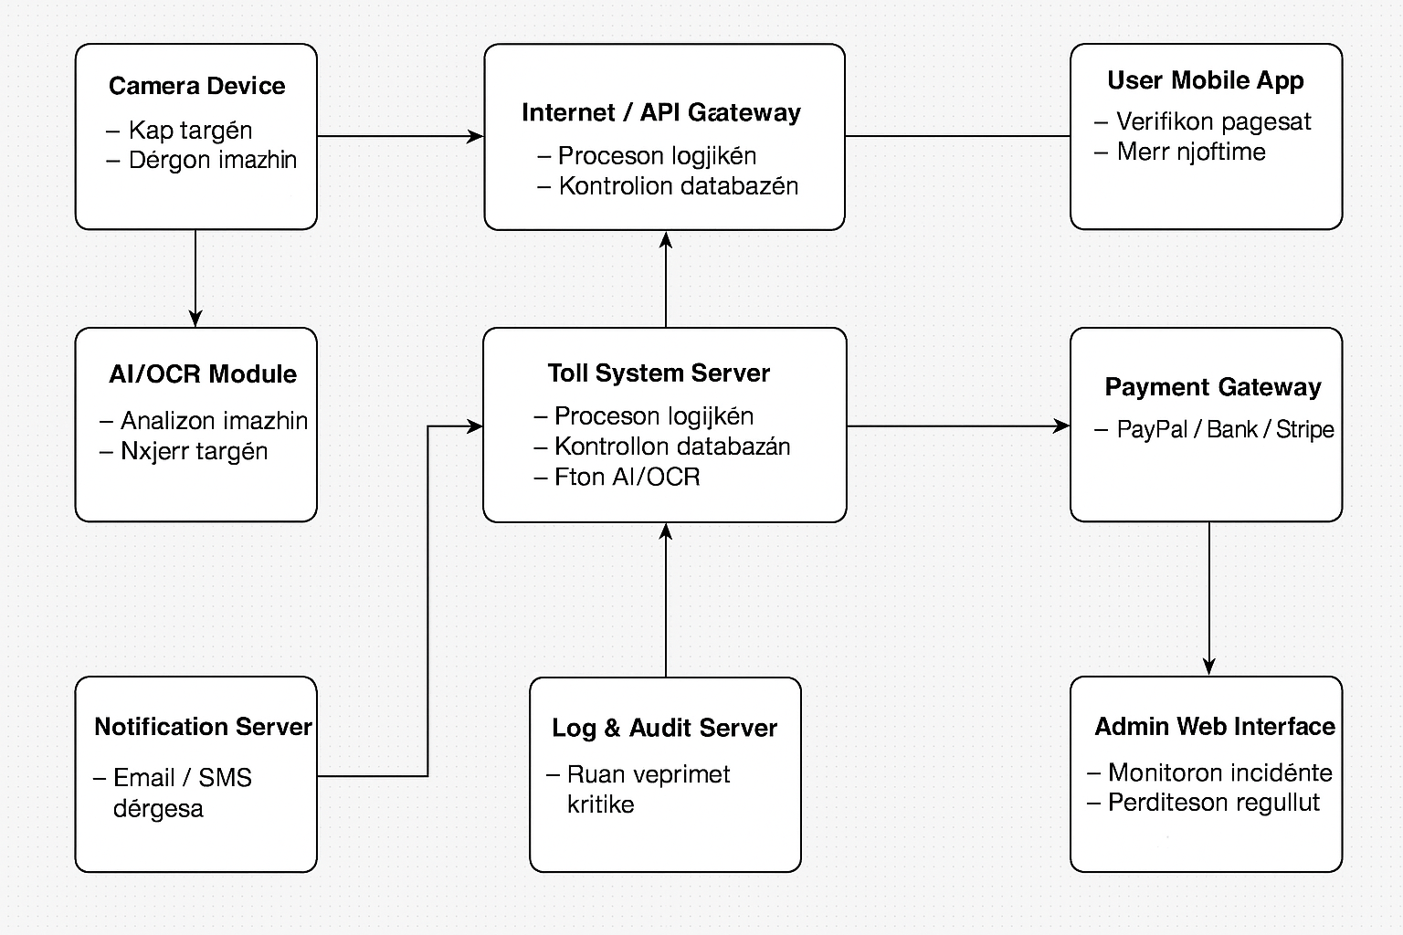

Worked: Alesia Gode

